Kerry Park Curling Centre League Safety Plan

League Play 2020/2021 Curling Season
1. IDENTIFICATION: | 15 August 2020, Version 1
Date of Modification | 15 August 2020
Next Review Due | 30 September 2020
Purpose | The purpose of this Kerry Park Curling Centre (KPCC) League Safety Plan is to provide information and guidance on the policies, measures and protocols which must be followed in order to implement a safe return to curling and to proceed with league play for the 2020/2021 curling season at the Kerry Park Recreation Centre (KPRC) in Mill Bay, BC. In conjunction with Kerry Park Recreation Centre’s Safety Plan https://www.cvrd.bc.ca/3306/Kerry-Park-Recreation-Centre-COVID-19, and through the implementation of this League Safety Plan, the KPCC Executive expects to limit transmission of the COVID-19 virus to the lowest threat level possible and to minimize the risk of exposure and illness. This League Safety Plan is subject to change dependant on COVID-19 trends, Public Health Authority direction, Curl BC guidelines or Kerry Park Recreation Centre direction.
Scope | This League Safety Plan is applicable to all registered curling participants in all leagues conducting play at the KPRC, any coaches or volunteers conducting or supporting KPCC sanctioned programs or events, and any associated guests/spectators under the control of any league participant, coach or volunteer for the 2020-2021 curling season. This is considered a “live” document and subject to change as required.
Process Sponsor | Kerry Park Curling Centre Executive
Process Owner | Kerry Park Curling Centre President

2. DEFINITIONS:

“Public Health Measures” include direction and guidance from the Public Health Agency of Canada (PHAC), the Centers for Disease Control and Prevention (CDC), BC Center for Disease Control (BC CDC) and HealthLinkBC.

Vulnerable people may include elderly, those at risk due to underlying medical conditions (e.g. heart disease, hypertension, diabetes, chronic respiratory diseases, cancer), or those at risk due to a compromised immune system from a medical condition or treatment (e.g. chemotherapy)

Asymptomatic: presenting no symptoms of a disease or illness.

A Non-Medical Mask: is a mask that fully covers the nose and mouth to prevent respiratory droplets from contaminating other people or surfaces in the immediate vicinity of the wearer.
Table of Contents:
3. Responsibilities
4. About COVID-19
5. Public Health Measures
6. Self-Assessment Screening
7. Exposure Control Strategies / PPE
8. Risk of Exposure
9. Transiting Procedures
10. Team Play Limited Occupancy Rooms
11. Hygiene Procedure
12. Handwashing Practices
13. Sanitization / Cleaning Procedures
14. First Aid / COVID-19 Exposure Protocol
15. Training
16. Document History
17. References & Related Documents
18. Annexes

3. Responsibilities:
3.1 Kerry Park Curling Centre Executive shall provide leadership and assume overall responsibility for the implementation of the COVID-19 League Safety Plan.
3.2 League Representatives shall be overall responsible for the implementation of KPRC Facility Safety Plan and the KPCC League Safety Plan within their respective leagues, identifying a League host as well as a league Safety Rep.
3.3 League Hosts shall be responsible for enforcing and promoting the KPRC Facility Safety Plan and the KPCC League Safety Plan and related COVID-19 policies, protocols and guidelines at every draw. Additionally, League hosts shall maintain a sign-in sheet for each draw and all sign-in sheets are to be submitted to KPRC management at a minimum of once per month.
3.4 League Safety Reps are responsible for dealing with any first aid needs that arise during league play. This includes safely and responsibly responding to accidents and injuries, calling or directing the call to 911 Emergency Services where warranted, knowing how to use the AED, informing KPRC staff of the incident and identifying KPRC staff supplies used / needed in the First Aid kit(s).
3.5 Individual Registered Participants are responsible to exercise personal duty of care to prevent the spread of the COVID-19 virus to others, follow the instructions and procedures outlined within both the KPRC and KPCC Safety Plans and strict adherence to all signage and protocols within the KPRC facility.

4. About COVID-19:
Coronavirus disease (COVID-19) is a virus that causes respiratory distress and illness. Symptoms may appear in as few as 2 days or as long as 14 days after exposure. The virus transmits readily through respiratory droplets. Exposure in a recreational/social setting can be due to direct contact with droplets or indirect contact through contaminated surfaces. The risk is heightened if insufficient exposure control plans are not implemented while participants attend facilities and/or participate in recreational activities. The best way to prevent exposure is to be well informed about the virus, the illness it causes and how it spreads. A thorough Safety Plan includes complying with basic public health strategies as well as implementing control measures to reduce the risk of exposure. This League Safety Plan is based on public health measures which recommend physical distancing and maintaining best hygiene practices, as well as control strategies that aim to reduce risks of exposure, and is in line with KPRC Facility Safety Plan requirements.
A SPECIAL NOTE (taken from Curl BC Return to Curling Guidelines): It is important that all individuals understand that when you choose to participate in physical activities outside the home during the pandemic – including curling – you may be at an increased risk of being exposed to and contracting the coronavirus. This is an inherent risk of participating in activities in your community where you may interact with other individuals. Curl BC considers curling to be a MEDIUM risk sport for the contraction of Covid-19 due to the colder climate and poorer ventilation of our indoor curling environments. Participants should carefully assess their personal health circumstances before engaging in curling activities.
5. Public Health Measures:
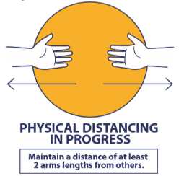
Public Health Measures are behaviours, actions or the wearing of non-medical equipment which reduce the risk of transmission and infection of viruses. Some of these measures provide you limited protection from others, but the most important feature is they PROTECT OTHERS from you in the course of your normal activities in the workplace and in the community.

These six important “Public Health Measures” provide the primary protective procedures
against exposures to the COVID-19 virus and shall be followed by all KPCC league participants:
- Washing your hands frequently;
- Avoid touching your eyes, nose and mouth;
- Coughing or sneezing into your sleeve;
- Cleaning all objects and surfaces you handle regularly;
- Maintaining physical distancing (a minimum of 2 meters, or 6 feet from others).
- Staying home if you feel unwell or sick (especially important during cold and flu season).

6. Self-Assessment Screening:
One of the best public health measures for controlling exposure is to stay home if unwell or when you have been in contact with someone who has been infected with or exposed to COVID-19. We all must remain responsible in stopping the spread of this virus. KPCC league participants, coaches, volunteers and guests shall stay home and seek medical direction if they answer positively to any of the following three questions below:
- Do you have any symptoms of feeling unwell that could include fever, chills, cough, shortness of breath, sore throat and painful swallowing, stuffy or runny nose, loss of sense of smell, headache, muscle aches, fatigue or loss of appetite? Also consider uncontrollable seasonable allergies symptoms that cannot be maintained by medications.
- Have you travelled out of Canada in the last 14 days?
- Are you providing care or have had close contact with a person with confirmed COVID-19?
The virus can also spread through people who do not display symptoms (Asymptomatic), therefore we all must exercise due diligence and duty of care to prevent the spread of the COVID-19 virus to others. Everyone must remain vigilant in washing their hands often, avoid touching their face and sanitizing what they have touched often. If we are all dedicated to the same level of expectation, we will ensure we maintain a safe curling environment.
Note: KPCC league participants and guests of participants shall conduct this Self-Assessment Screening questionnaire each time before they leave home and/or enter the KPCC. If in doubt, they are to STAY HOME , contact your team/skip, and seek medical direction through their doctor or complete the online health assessment at: https://bc.thrive.health/ or dial 8-1-1 to speak with the HealthLinkBC Hotline.

7. Exposure Control Strategies:
The KPCC shall endeavour to protect personnel from exposure to the COVID-19 virus and help maintain physical distancing and reduce close contact with others through a combination of Exposure Control Strategies. These are Health & Safety guidelines to help maintain physical distancing and plans to help reduce exposure. They are based on the proven Hierarchy of Controls, listed in order of preference:

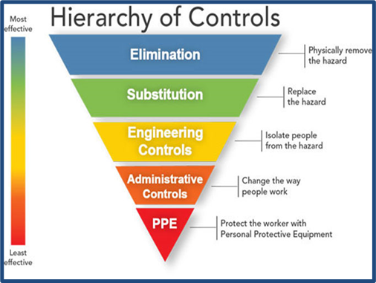
- Elimination & Substitution:
Participants shall stay home when ill or having been in contact with someone who has a confirmed case of COVID-19.

- Engineering Controls:
Engineered controls will be at the discretion of the KPRC and could include systems such as installing plexiglass barriers at key locations, or restricting access if deemed necessary.

- Administrative Controls:
Administrative controls include the ongoing review and amendments to this League Safety Plan. The KPCC Executive and/or KPRC will ensure the following administrative controls are in place:
  - pedestrian traffic flow directions provided at walkways, on doors, stairways and hallways to promote physical distancing;
  - promoting “Public Health Measures;”
  - posting instructions and warning signs at key locations to inform personnel of suitable controls measures;.
  - installation of physical distancing decals in the curling ice;
  - adapting a thorough sanitization and cleaning procedure;
  - adding hand sanitizing stations throughout the facility;
  - develop a league schedule that allows sufficient sanitization time between draws (where applicable).
  - assigning maximum occupancy numbers for meeting rooms, lunch rooms and washrooms to promote physical distancing and help reduce gatherings.
  - KPCC Executive shall define the maximum safe number of participants per league draw.
  - KPCC lounge tables will be set up to maximize physical distancing.
  - ongoing commitment to further development of this Safety Plan through league participant feedback and suggestions, as well as any updated guidelines provided by health authorities, Curl BC or KPRC.
  - communicating updates through the KPCC website, Facebook Page, league reps and the 20/21 KPCC Registered Participant Email List (once developed).

- Personal Protective Equipment (PPE)
PPE is the last line of defense and should always be used in conjunction with other control measures outlined in the “Public Health Measures” and “Exposure Control Strategies”. All KPCC league participants shall have their own curling equipment. There will be no sharing of equipment. There is to be no switching of rocks between team members. The wearing of non-medical face masks during play is optional. When entering the KPRC facility and when in the social lounge, washrooms, etc, the wearing of a mask is now considered mandatory when attending for the purposes for league play or any other KPCC sanctioned event.

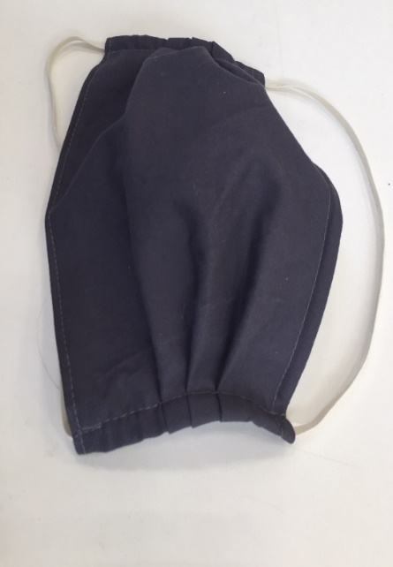
Note: A Non-Medical Mask is a mask that fully covers the nose and mouth to prevent respiratory droplets from contaminating other people or surfaces in the immediate vicinity of the wearer. Wearing a Non-Medical Mask is considered a public health measure that will PROTECT OTHERS from you, specifically when within physical distances. Research shows that individuals who do not routinely wear a Non-Medical Mask or other masks, touch their face more often, through making adjustments or donning/doffing incorrectly, increases the risk of transmission. Extra care must be given when wearing these Non-Medical Masks. They can become contaminated during use. You should avoid moving these masks around or adjusting them often. They should never be shared with others. It is the responsibility of league participants and guests/spectators to ensure they carry an appropriate Non-Medical Mask at all times (wear during play is optional) and to advise respective league safety reps of any unforeseen hazards.

- Non-Medical Masks are non-medical face coverings and will NOT filter the COVID-19 virus or protect you from being infected; it protects others around you.
- The Non-Medical Mask acts as a barrier that helps stop droplets from spreading when you talk, cough or sneeze.
- Non-Medical Masks should be well-fitted (non-gaping).
- Wash your hands immediately before putting the Non-Medical Mask on and immediately after taking it off.
- The wire (if there is one) on the front and top of the covering is to be shaped to fit around the nose.
- When not worn, the Non-Medical Mask should be stored in a clean, dry area.
- Change the Non-Medical Mask as needed- when it becomes damp or dirty.

8. Risk of Exposure:
The risk of exposure to the COVID-19 virus at the KPCC is considered low at this time (will be reassessed regularly based on coronavirus trends and Public Health Authority recommendations). This risk level can be maintained by following the “Public Health Measures” and the “Exposure Control Strategies” to help maintain physical distancing and limit close contact with others.
It is recognized there will be situations where, during the course of play, participants may not always be able to maintain the 2 meter physical distancing protocol.
Note: The Center for Disease Control and Prevention (CDC) defines “Close Contact” as being within 2 meters for a continued period of time, greater than a few minutes in duration.
- It is of utmost importance that all league participants follow the directions outlined in the Self-Assessment Screening and stay home when unwell;
- League participants shall follow the six “Public Health Measures”, and maintain physical distancing; this includes standing on the physical distancing decals when not involved in the delivery or sweeping of a rock or acting as the skip/vice skip;
- Individuals should consider wearing a non-medical mask as outlined in section 7 above (everyone shall carry a non-medical mask with them at all times when proceeding to the KPCC); and
- All league participants shall adhere to “Exposure Control Strategies” to keep the risk environment low. (Note that alternating start times by 15 minutes for sheets 1 and 3 and sheets 2 and 4 should be considered).
- Transiting Procedure:
All league participants and guests of participants shall follow all signage put in place by KPRC to indicate direction of travel outside and inside the building as well as identified entrance and exit doors and physical distancing markings.
- Team Play / Facility Room Limitations:
Curl BC has implemented a phased approach to for the Safe Return to Curling. All KPCC league membership shall follow the limitations of play as outlined in the respective phase that is in place. We are currently operating in phase 3. Limitations within this phase are as follows:
- Clubs/Centres progressively open;
- 2m Physical Distancing;
- No events >50 people; Local community participation only;
- Modified play; Individual/Family practices; Skill development activities; Non-contact training;
- 2 person games* Doubles play / teams split to form 2 shorter games of doubles play;
- 3 person modified games * Max 3 players per team on the ice, 1 sweeper only per rock, ensure physical distancing can be maintained;
- 4 person modified games * 1 sweeper only per rock, ensure physical distancing can be maintained. Sweepers rotate or one person does not play
- No bonspiels; No or limited spectators
Rules of Play: As you can see, under phase 3 the traditional 4 player team concept (2 sweepers per rock) is not allowed. Should Curl BC decide to move to phase 4, traditional 4-person team play will be allowed and bonspiel play will resume. Adjusted rules of play as follows:
- The maximum capacity of the social lounge is currently 40.
- The change room adjacent to the lounge will be closed and locked and there will be limited occupancy in washrooms so curlers shall arrive at the KPCC dressed for play (minus curling shoes on).
- All leagues will maintain a sign-in sheet for players and guests for each draw that shall be turned in to Kerry Park Management – preferably after every draw but at the very minimum of once per month.
- All KPCC league participants, coaches, volunteers and guests/spectators shall follow KPRC signage related to physical distancing. The KPCC Lounge area will be set up to respect physical distancing measures. There should be no more than 4-persons seated to 1 table at any time and there will be no moving of tables / joining of tables together.
- If the bar/food service does eventually open, all persons shall follow distancing signage and protocols when waiting to be served.
- An example diagram of ice layout to control physical distancing can be found on the KPCC website. Physical distancing markers will be placed in the ice indicating where player will stand when not directly involved in the sweeping or delivery of the curling rock or acting as the skip/vice.
- Wearing of gloves are optional during play however all personnel must avoid touching other player’s curling rocks with their hands. When removing rocks from play, it shall be done so using the broom or your feet. Only the vice skips should touch the scoreboards
- No shaking hands or close contact gesters with opposing players at the start or end of play. Touching brooms with opposition players from a distance is an acceptable form of signaling sportsmanship between players / teams.
- Staggered start times should be considered by all leagues (i.e. sheets 1 and 3 start play followed 10-15 mins later by sheets 2 and 4). Minimum of 1 hour spacing between draws.
- Only 1 sweeper per rock between the T lines. The skip of the delivering team may take over sweeping the rock after it crosses the house of play T line.

- Hygiene Procedure:
All persons are to practice best hygiene procedures that are designed to assist in reducing the transmission of the COVID-19 virus. Those procedures include the following:
- Regular handwashing; Coughing and sneezing into elbow or tissue;
- Nose blowing - use enough layers of tissue paper so that the fingers do not touch the secretions;
- Immediately dispose of tissue paper in a garbage can with a bag and lid, if possible • Wash / sanitize hands.

- Handwashing Procedure:
- Wash your hands frequently. Hands shall be washed first thing upon arriving at the KPCC.
- Wash after touching high touch points (doors, handles, etc), as well as immediately on completion of play after leaving the ice surface.
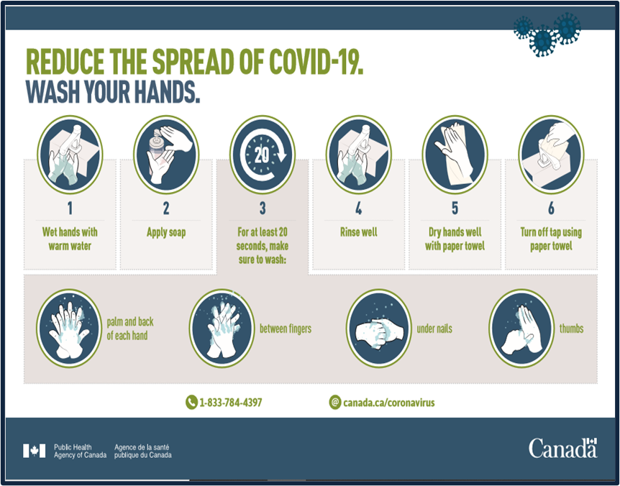
- Handwashing should also occur after handling any common materials or equipment.

- Sanitization / Cleaning Procedures:

KPRC staff will handle cleaning and sanitizing the facility and ice area (including rocks) after each draw.

- First Aid / COVID-19 Exposure Protocol:
No person shall visit the KPCC for league play or any other KPCC sanctioned program or event if they feel ill in any way (even the mildest of symptoms such as fever, chills, new or worsening cough, shortness of breath, sore throat, and new muscle aches or headache),
Individuals who start to feel unwell with COVID-19 like symptoms (fever, chills, new or worsening cough, shortness of breath, sore throat, and new muscle aches or headache), while attending KPCC for the purposes of curling/spectating during league play or other KPCC sanctioned programs or events shall make themselves known to the respective league safety rep, or in their absence, KPRC staff. Such persons are to identify themselves, wash and sanitize their hands, put on a non-medical mask, be directed to go straight home and consult the BC COVID-19 Self-Assessment Tool, or call 811 for further guidance related to testing and self-isolation. Further, should an individual who has attended the KPCC be tested for COVID-19, said person shall make it known to their League Rep and the KPCC Executive, the results of their assessment. Where a positive case of COVID-19 has been confirmed a response protocol shall be coordinated by KPCC Executive and KPRC Management with an investigation and recommendations to follow.
For any other accidents or emergencies, league safety reps, or another individual in their absence, shall call 911 for emergency services where warranted. If an incident or injury requires onsite First Aid treatment, including the use of an Automated External Defibrillator (AED), the person(s) providing the treatment are to ensure they protect themselves first – including wearing a mask and gloves.
Each league conducting play at the KPCC shall have a designated First Aid person (preferably someone current in a minimum of First Aid Level 1 with AED).

15. Training
Where/if possible, KPCC, in collaboration with KPRC, will look to provide training to enable a safe and successful 2020/2021 curling season.

16. Documentation History:
Date | Description of Change | Changed By | Modification #
24 Jul 20 | Draft Documented created | - Downey
05 Sep 20 | Document Amended | D. Downey | 1
12 Sep 20 | Changes based on Curl BC Phase 3 Recommendations and discussion from 09 Sep 20KPCC Executive/League Rep Meeting to include:  - Wearing of curling gloves now optional when throwing the curling rock;  - Wearing of masks is now mandatory when entering the building and while in the curling lounge (will be adjusted should food and beverage services be returned;  - Guests/spectators are discouraged from watching league play in phase 3.  - Additions to rules of play in section 10. | D. Downey | 2

17. References & Related Documents:
- Canadian Occupational Health & Safety Legislation
- WorkSafe BC
- Centre for Disease Control and Prevention (CDC)
- Public Health Agency of Canada (PHAC)
- British Columbia Centre for Disease Control (BCCDC)
- HealthLink BC (Self-Screening Assessment)
- Curl BC Safe Return to Curling Guidelines
- Kerry Park Recreation Centre Facility Safety Plan
18. Annexes
- Kerry Park Recreation Centre COVID-19 Addendum to Facility Use Agreement/License (KPCC Executive)
- COVID-19 Declaration of Compliance Form (all league participants)
- Health Declaration Sign-In Sheet (all league participants and guests – every draw)
- Waiver of Claims and Indemnity Agreement – Age of Majority (all applicable league participants)
- Waiver of Claims and Indemnity Agreement – Under Age of Majority (all applicable participants)
- Kerry Park Curling Centre Illness Policy (all participants/guests to read and abide by)

